Year 8 |  | Percentages and Financial Maths | Non Calculator  Section
Skills and Knowledge Assessed:  - Connect fractions, decimals and percentages and carry out simple conversions (ACMNA157)  - Find percentages of quantities and express one quantity as a percentage of another, with and without digital technologies (ACMNA158)  - Solve problems involving the use of percentages, including percentage increases and decreases, with and without digital technologies (ACMNA187)  - Investigate and calculate Goods and Services Tax (GST), with and without digital technologies  - Investigate and calculate ‘best buys’, with and without digital technologies (ACMNA174)  - Solve problems involving profit and loss, with and without digital technologies (ACMNA189) |  |  | Name___________________
Answer all questions in the spaces provided on this test paper by:
Writing the answer in the box provided.
or
Shading in the bubble for the correct answer from the four choices provided.
Show any working out on the test paper. Calculators are not allowed.
 | 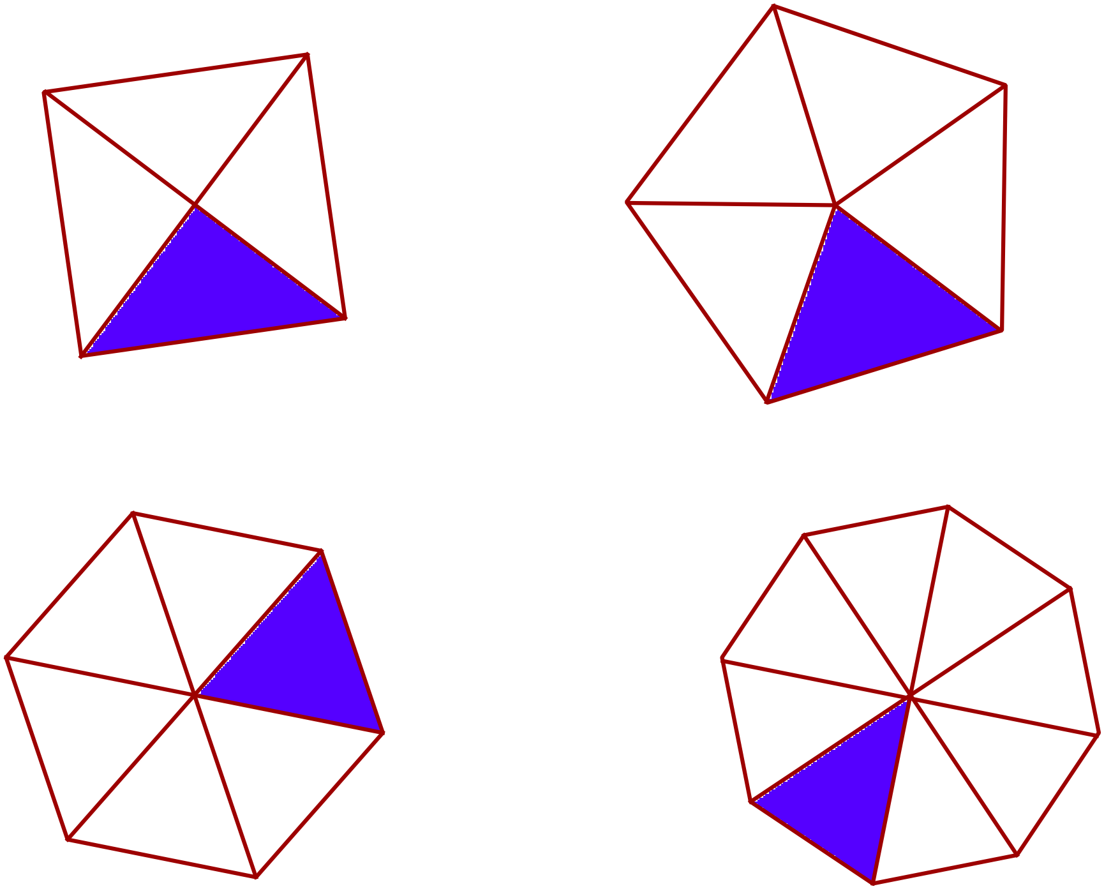Which diagram has  shaded?
 | Write 80% as a fraction in simplest form.
 | Write 37% as a decimal number.
 | Convert the fraction 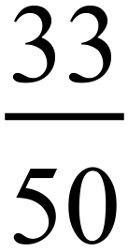 to a percentage.
What is 52% of 400?

52 104 208 312
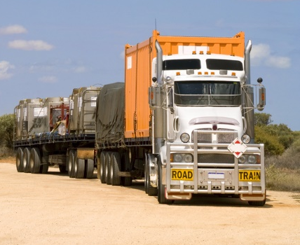
A loaded truck has a mass of 50 tonnes. Its load makes up 70% of this mass.
What is the mass of the load?

Joe’s dad wins $ 240 in a raffle and gives 35% of this to Joe.
How much did Joe receive?

$35 $42 $70 $84

Billie turns over 20 cards on a table and finds that 14 of them are picture cards.
What percentage of the cards that she turned over were picture cards?

Which fraction is equivalent to 35% ?


 | Write the decimal 0.472 as a percentage.
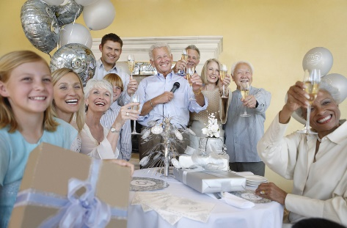
At a birthday party 20% of the people are adults, 45% are girls and the remainder are boys.
What percentage of those at the party are boys?

25% 35%
45% 65%
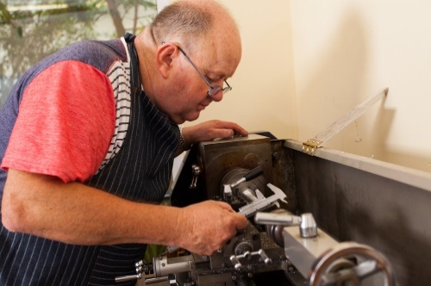
In September Mr Robinson made 60 wooden toys in his workshop.
In October he made 72 wooden toys.
What is the percentage increase in October compared to September?

A clothing store sells shirts for $24.00 plus GST.
What is the price when 10% GST is included?

A car dealer bought a used car for $8 000 and later sold it for $12 500.
What was the percentage profit when selling the car?

12.5% 45%
56.25% 80%
A store sells a packet of cereal for $5.20.
The store added a 30% profit to its cost price to achieve the selling price.
What was the cost price?

$1.30 $2.00 $2.60 $4.00
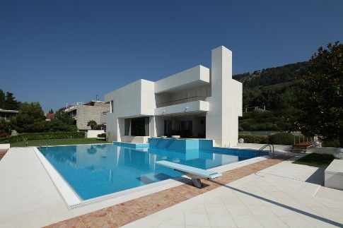
Michelle bought a house for $500 000 and sells it later for $460 000.
What was her loss as a percentage of the cost price?

Which is the better buy, 1.5 litres of soft drink for $6.30 or 250 ml for $1.50? Explain why.

……………………………………………………………………..

……………………………………………………………………..

……………………………………………………………………..
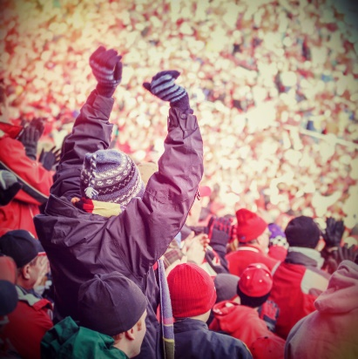
In a sporting crowd, 24% are found to be wearing football jerseys.
If 6000 were wearing football jerseys, how many were in the crowd?

Year 8 |  | Percentages and Financial Maths | Calculator Allowed  Short Answer  Section
 |  |  | Name___________________
Answer all questions in the spaces provided on this test paper by:
Writing the answer in the box provided.
or
Shading in the bubble for the correct answer from the four choices provided.
Show any working out on this test paper. Calculators are allowed.
What fraction is the same as 26% ?

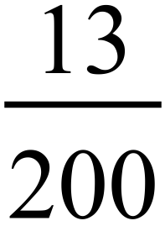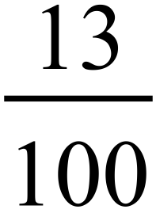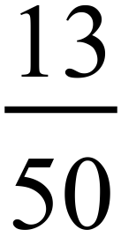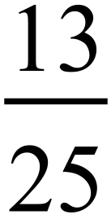
Louise counts her CD’s and works out that 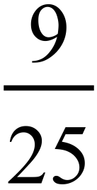 of them are by her favourite band.
What percentage does this represent?

 | What is 87.5% when written as a decimal?
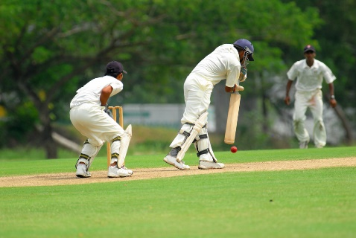
The coach of a cricket team finds that of the 15 regular players in the squad, 3 are unavailable to play.
What percentage of the squad is unavailable?

George told his mum that he had finished 45% of his assignment.
If this is true, what percentage does he still have to do?
45% 55%
65% 75%
What is 31.25% of $ 3 200?

$ .
 | 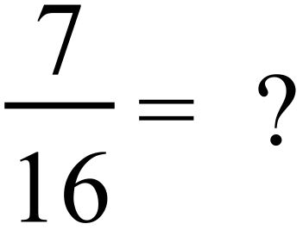
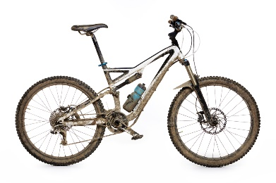
Russell spends 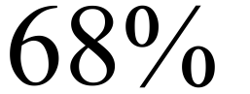 of his leisure time riding his bike.
If his weekly leisure time totals 25 hours, how much time does he spend riding?
15 hours 16 hours
17 hours 18 hours
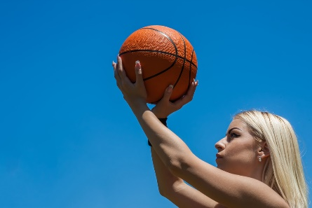
Kim is a basketball player.
In the latest competition, she had 180 shots at goal and was successful with 153 of them.
What percentage of her shots were successful?

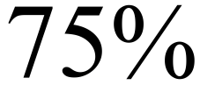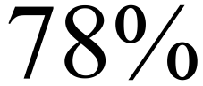
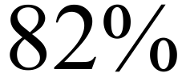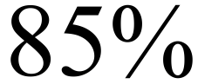
Sarah runs a lemonade stand at the school fete and buys all the ingredients for 20 glasses of lemonade for $11.25.
She sells the lemonade at 90 cents per glass.
What percentage profit does she make, if she sells all the lemonade that she makes?

A car costs $28 160 from a dealer, including GST.
A charity buys the car and does not have to pay GST.
How much would they pay for the car?

There are 250 students in Year 8 at Ashleigh High School.
A group of 40 students from Year 8 went on an excursion.
Of this group, 7.5% were given commendations for helping with the organisation of the excursion.
What percentage of the school year were given these commendations?

1.2% 1.5% 2.4% 3.0%
In 2015, Declan’s income from his hobby decreased by 27% compared to 2014.
His income in 2014 was $1 360.
If it continued to decrease at this annual percentage rate, what would be his income in 2016?
Answer to nearest 5 cents.

$

Write the following in order from smallest to largest.

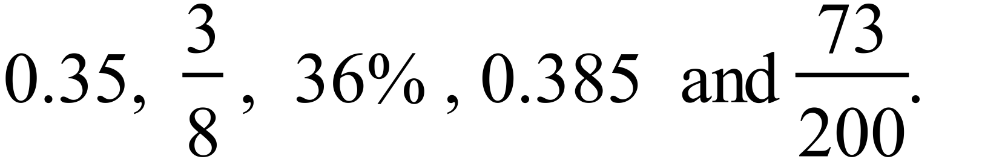

Year 8 | Percentages and Financial Maths | Calculator Allowed  Longer Answer  Section
 |  | Name___________________
Write all working and answers in the spaces provided on this test paper.
Marks may not be awarded if working out and/or answers are not clear.
Marks allocated are shown beside each question.
Calculators are allowed.

 |  | Marks
 | The Getaway Company offers 4 different holidays at Esperance Resort.  Meals purchased at the resort cost $65 per day per person.  A seven day Weekly Escape which includes all meals for $1 400 per person.  A two day Weekend Escape which does not include meals for $350 per person.  A four day Midweek Escape which includes meals for $760 per person.  Which Escape is the best value for money, assuming that meals are required?  (Explain how you determined your answer.)  ……………………………………………………………………………………..  ……………………………………………………………………………………..  …………………………………………………………………………………….. | 3

 | Mike has an allowance of 600 minutes talk time per month on his mobile phone, for a monthly cost of $ 36.50.
 | - Mike has currently used 210 minutes of his talk time.  What percentage of his time remains?  ……………………………………………………………………………………..  …………………………………………………………………………………….. | 1
 | - Mike gets a text warning when he has only 10% of his allowance remaining.  If Mike uses 30 minutes of his talk time each day on average, how many days into each month will he receive the warning message?  ……………………………………………………………………………………..  …………………………………………………………………………………….. | 1
 | - Mike can purchase extra time at a cost which is 20% more per minute than his normal plan. What would it cost him to purchase an additional 300 minutes?  ……………………………………………………………………………………..  …………………………………………………………………………………….. | 1

Year 8 |  | Percentages and Financial Maths | Non Calculator  Section
ANSWERS
No. | WORKING |  | ANSWER
 | 1 out of 5 which is 20% is shaded in the 2nd diagram |  | 2nd answer
 | 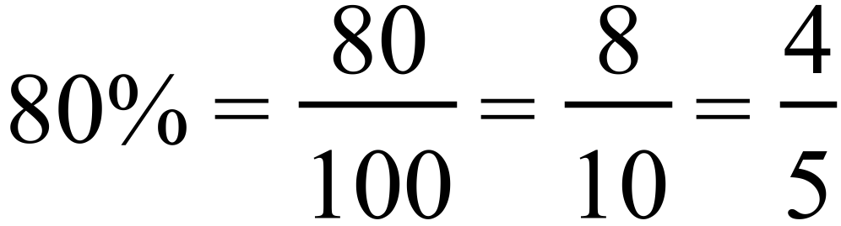 |  | 
 | 37% =0.37 |  | 0.37
 | 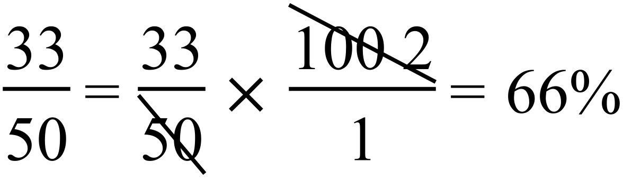 |  | 66%
 | 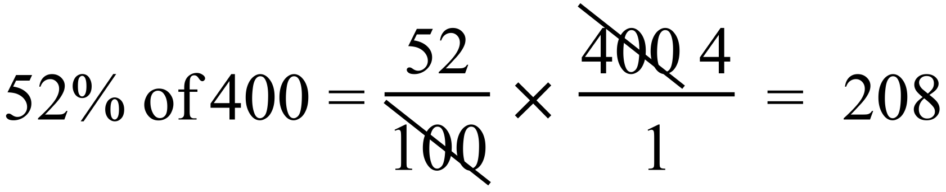 |  | 3rd answer
 | 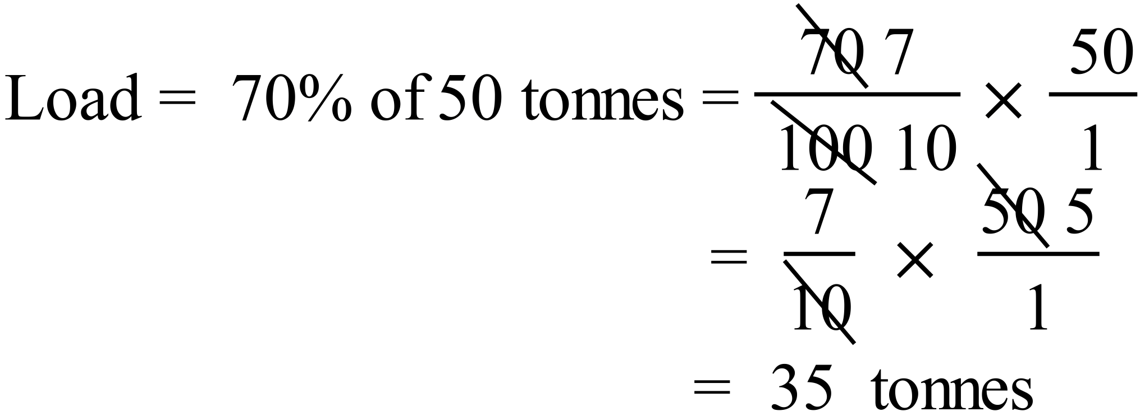 |  | 35 tonnes
 | 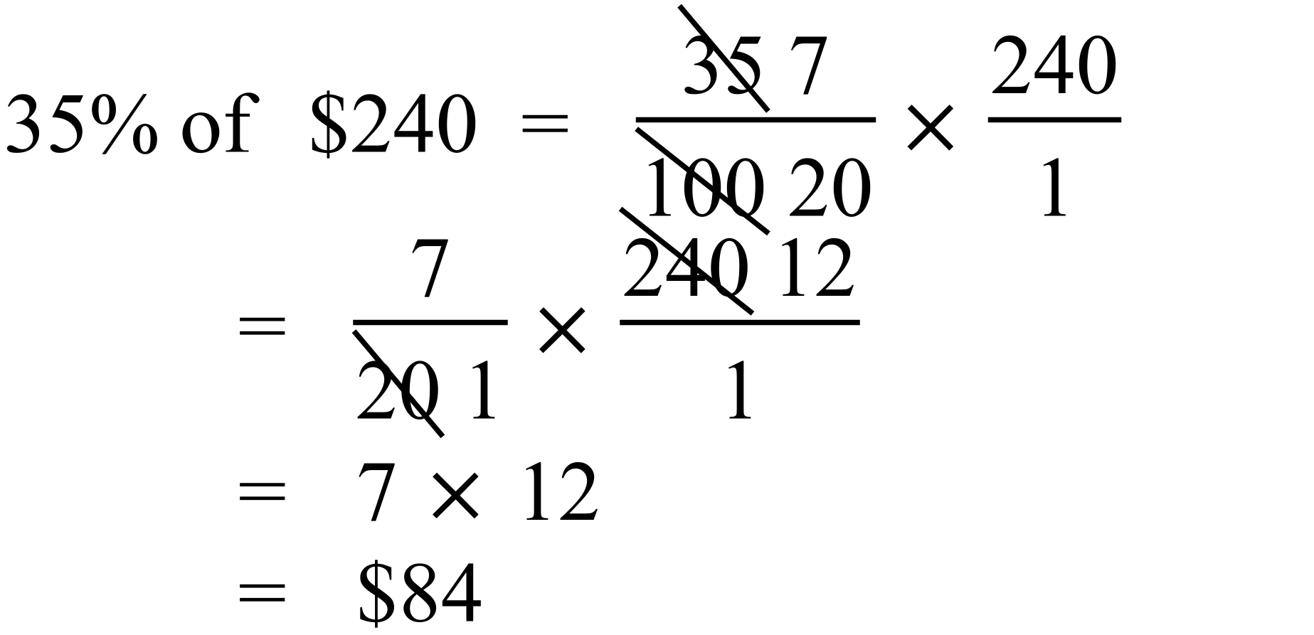 |  | 4th answer
 | 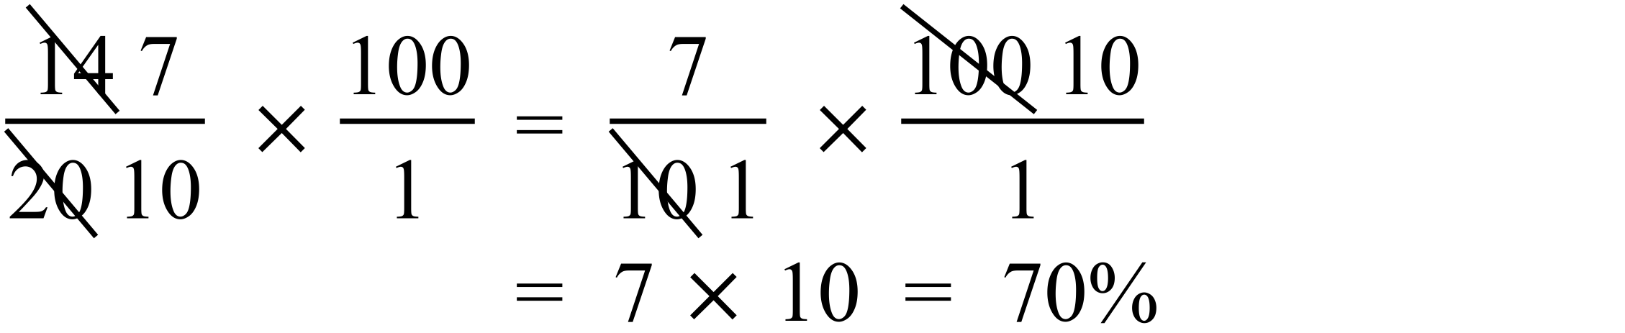 |  | 70%
 | 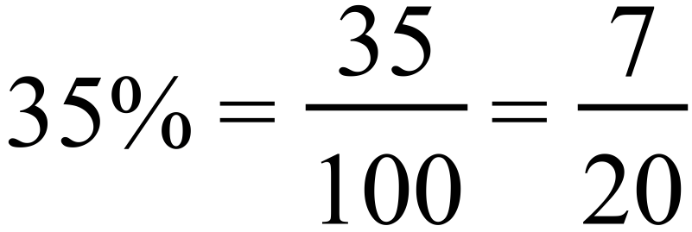 |  | 1st answer
 |  |  | 47.2%
 | Adults and girls make up 65% of total.  This leaves 35% who are boys. |  | 2nd answer
 | Increase = 12 toys  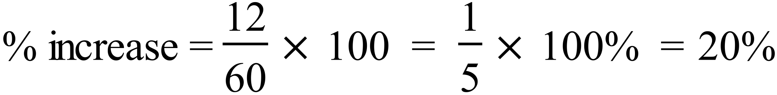 |  | 20%
 | 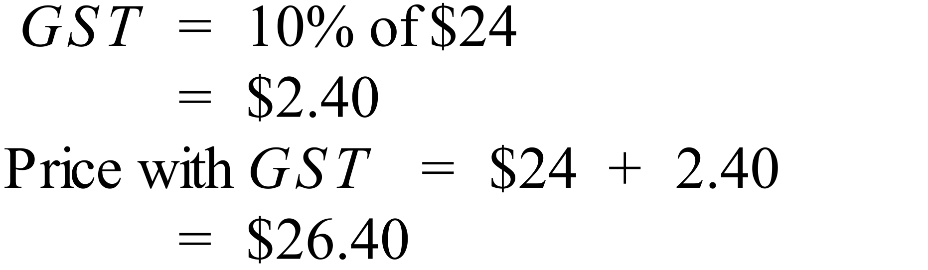 |  | $26.40
 | 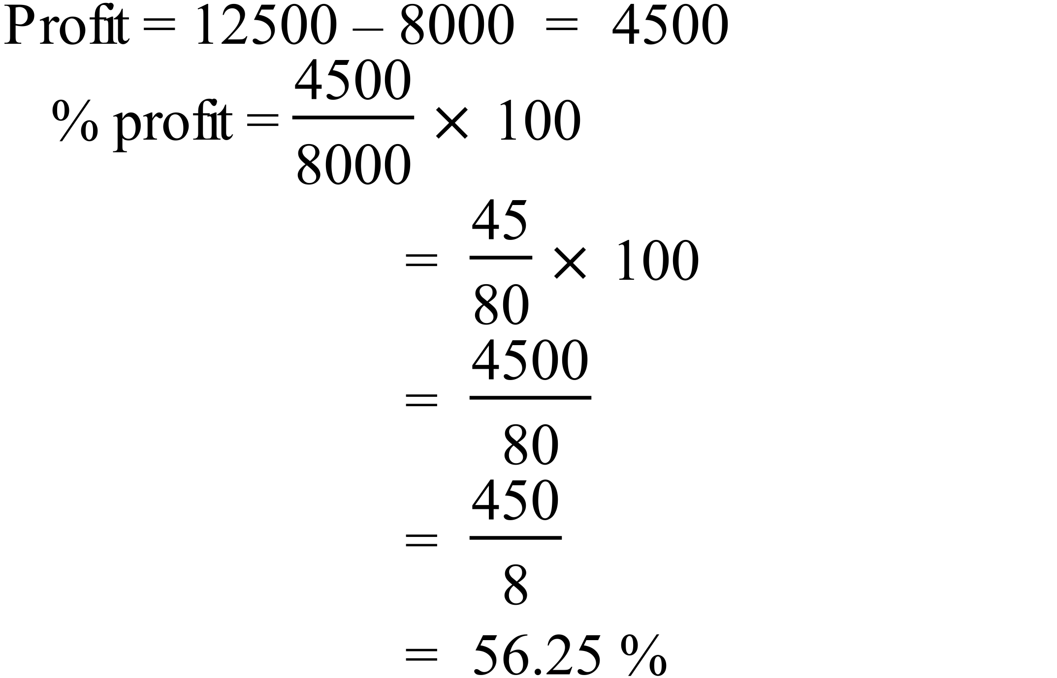 |  | 3rd answer
 | 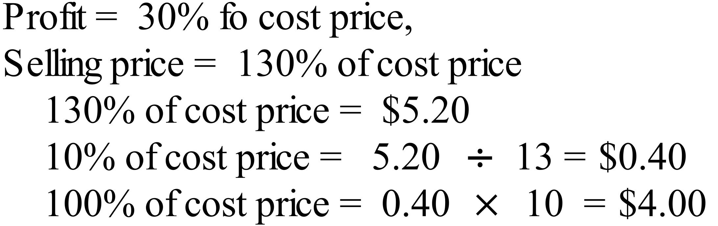 |  | 4th answer
 | 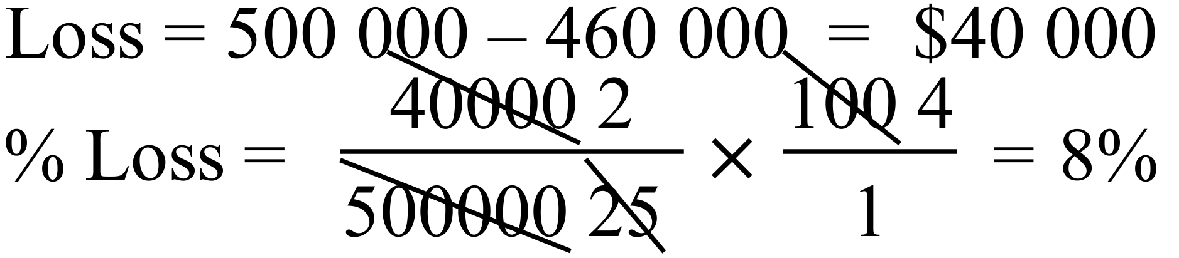 |  | 8%
 | 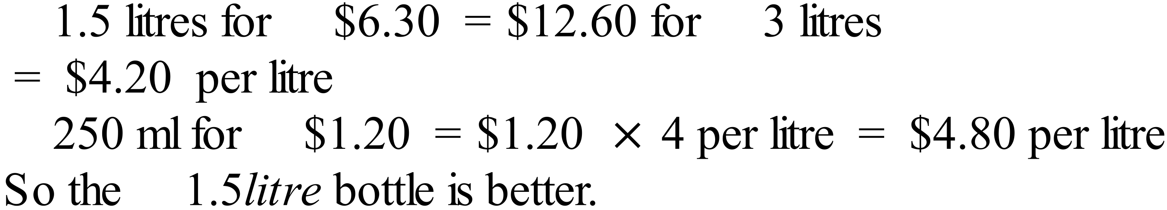 |  | 1.5 litre is better, need explanantion
 | 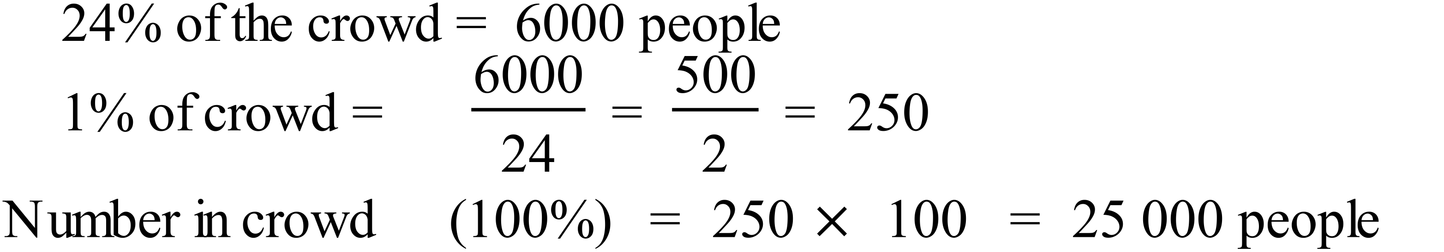 |  | 25 000

Year 8 |  | Percentages and Financial Maths | Calculator Allowed  Short Answer  Section
ANSWERS
No. | WORKING |  |  | ANSWER
 | 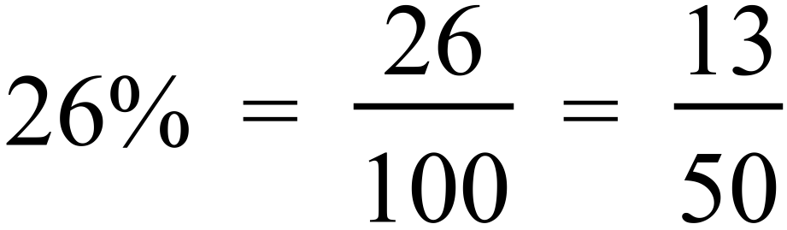 |  |  | 3rd answer
 | 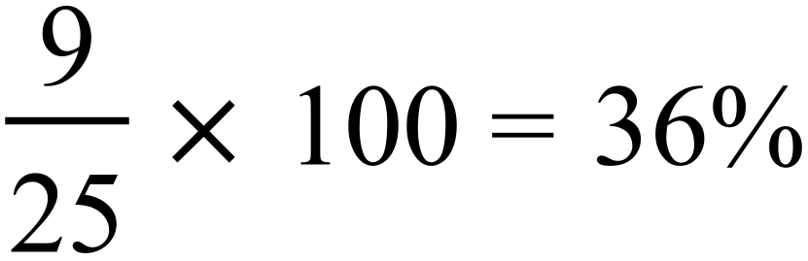 |  |  | 36%
 |  |  |  | 0.875
 | 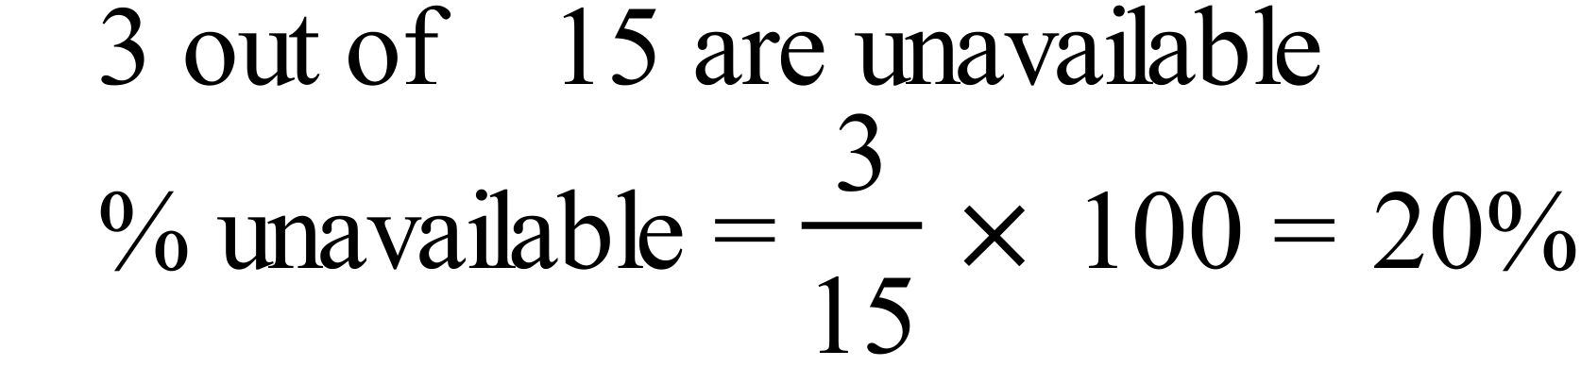 |  |  | 20%
 |  |  |  | 2nd answer
 | 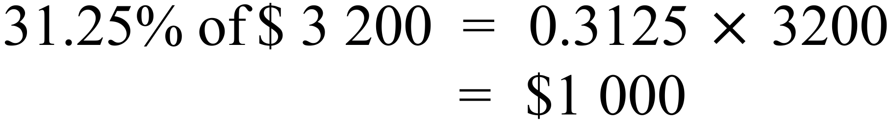 |  |  | $1 000
 | 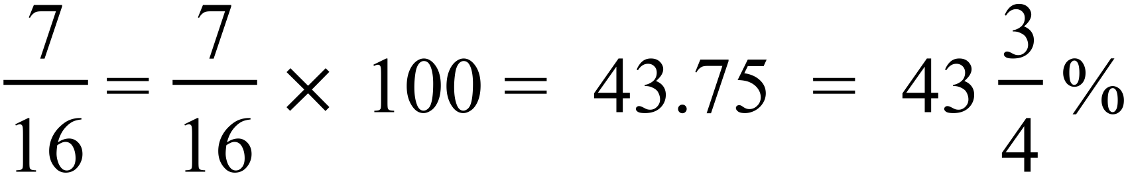 |  |  | 1st answer
 | 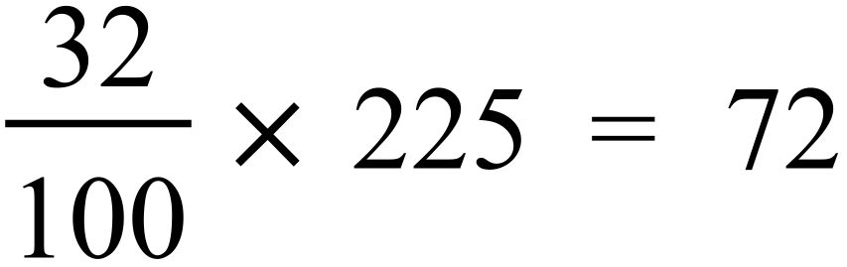 |  |  | 4th answer
 |  |  |  | 3rd answer
 | 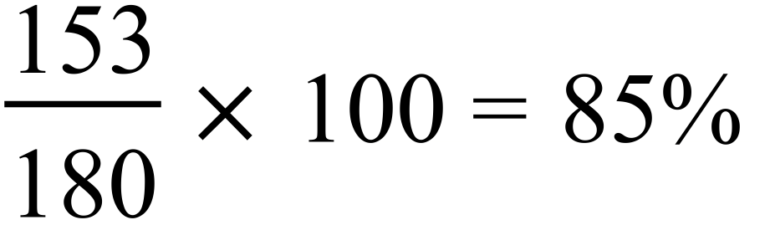 |  |  | 4th answer
 | 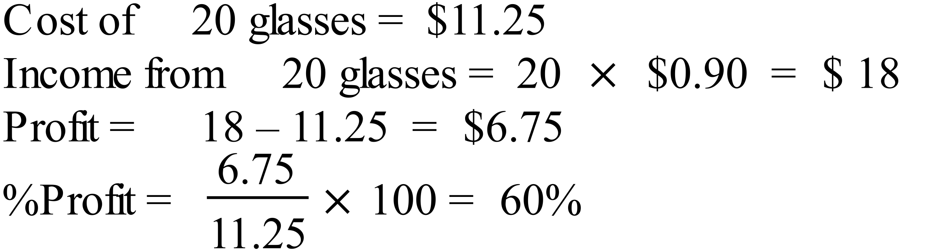 |  |  | 60% profit
 | 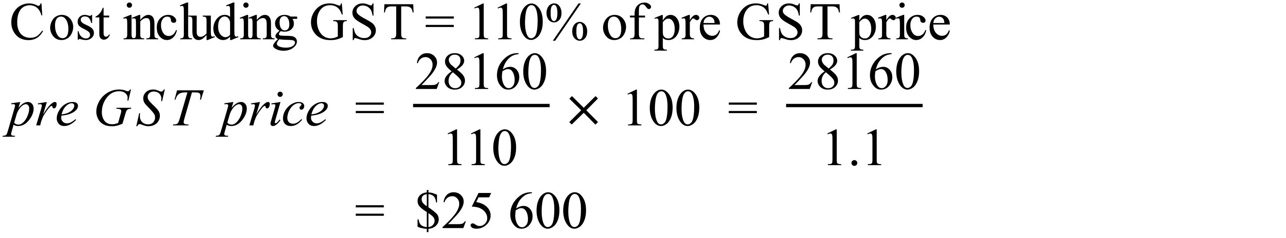 |  |  | $25 600
 | 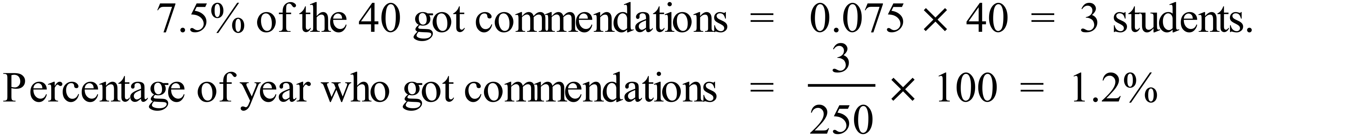 |  |  | 1st answer
 | 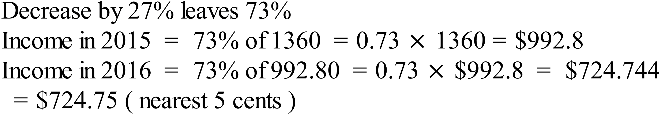 |  |  | $724.75
 | 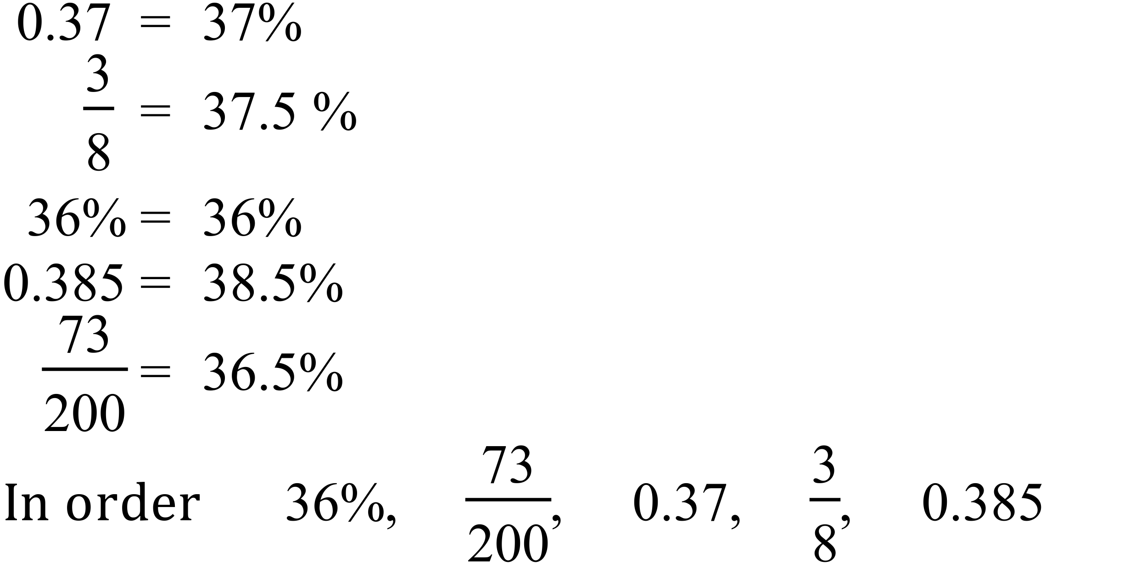 |  |  | In order as shown

Year 8 |  | Percentages and Financial Maths | Calculator Allowed  Longer Answer  Section
ANSWERS
 |  |  |  |  | Marks
 | 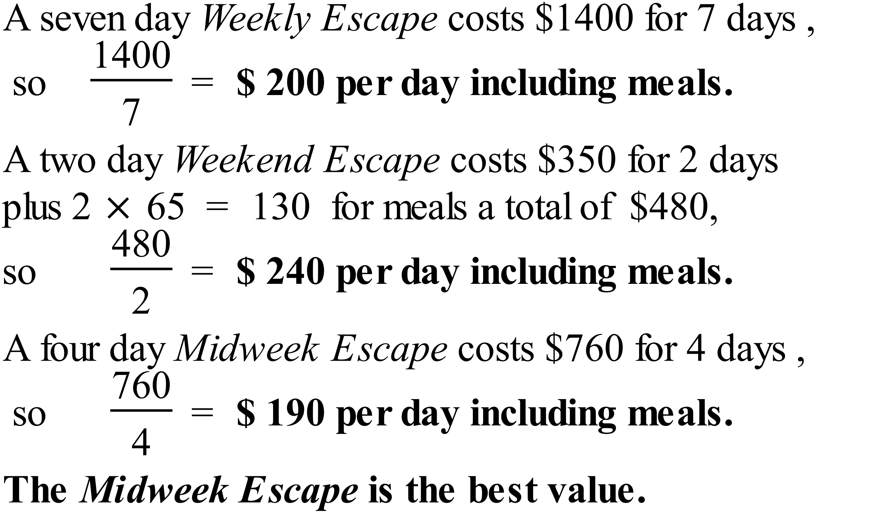 |  |  | 2 marks for calculations similar to those shown for a comparative rate.  1 mark for comparing and giving correct answer.
 | - Used 210 minutes, so 600- 210 = 390 remain.  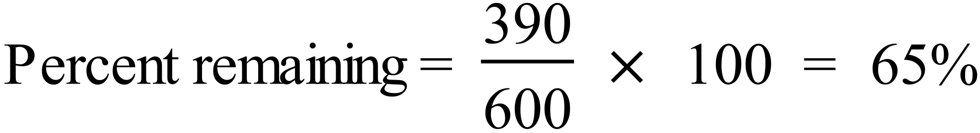 |  |  | 1
 | b)  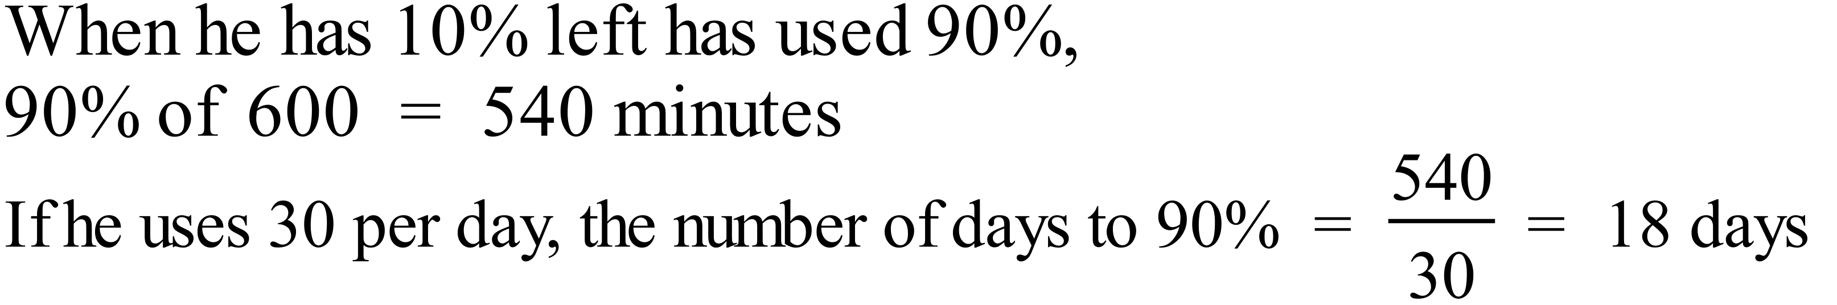 |  |  | 1
 | c) 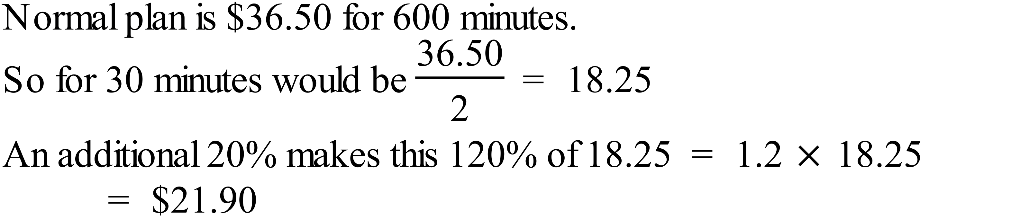 |  |  | 1

